Lei Cao

Project 3 - CSC311 Fall 2017

Instructor: Dr. Chatterjee

All the requirements have been fulfilled.

1. This screenshot is to show to passengers’ arrival sequence.
2. The boarding time starts at 15:30:00. Passengers start arriving from 15:25:20. The time interval between each passenger’s arrival is 40 seconds.
3. The boarding time window is 10 mins, covering from the arrival of the first passenger to the start boarding time of the last passenger.
4. The passengers arrive before start-boarding time do not get aboard. They are only enqueued into the priority queue and wait to get dequeued(get aboard).
5. When it’s time to board, the passengers who are already in the priority queue get aboard in the order of their priorities ( from small numbers to high numbers).
6. In the meantime, more passengers are coming. They are enqueued one by one when they arrive. However, anyone already in the priority queue with the same priority will be boarded first as followed by the first-come-first-served rule.
7. If anyone is being boarded during the 20 seconds boarding time window, any other newly arrived passenger with higher priority(smaller number) cannot overpass him/her after he/she is already being received.

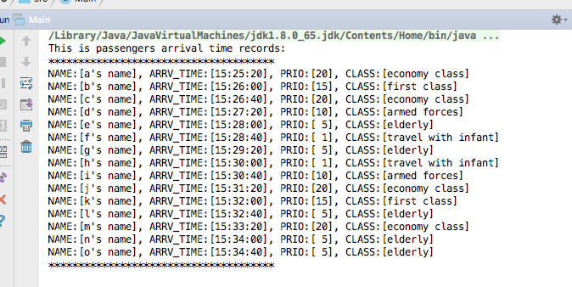

This screenshot is not a part of the project. It is only to show the dynamic process of how each passenger is enqueued and dequeued by the Priority Queue.

The designed time to board is 15:30:00. So you can see the first passenger gets board at 15:30:00(remove 01(f))

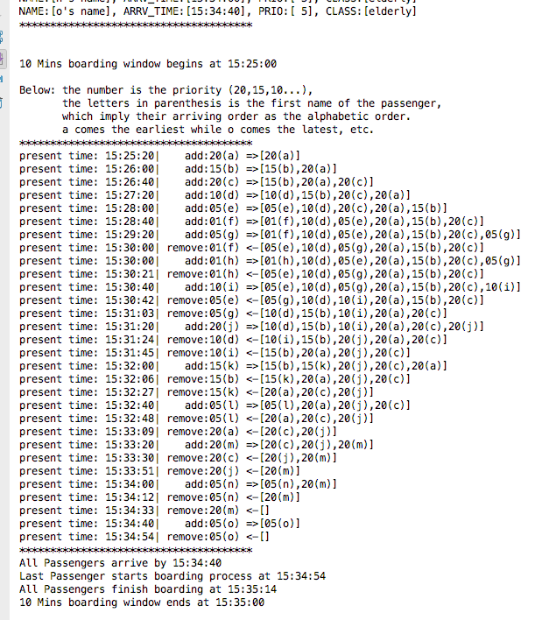

This screenshot is the final output as required.

The top list is the arrival sequence.

The bottom list is the boarding sequence. The required rules can be checked against the sequences:

Note: Date Of Birth is in the attribute of every passenger, but is not included in the print list, because Date Of Birth is considered confidential, it should not be printed.

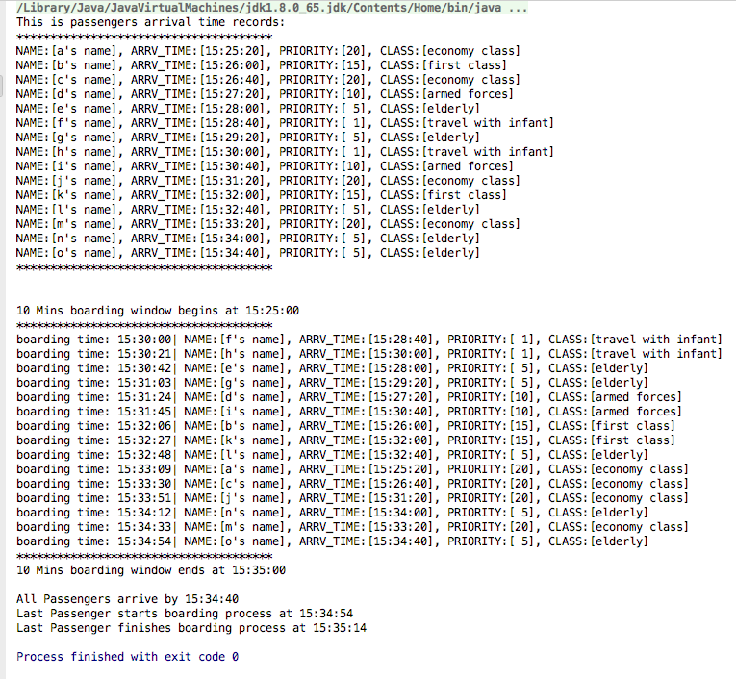

The output with some code snippets:

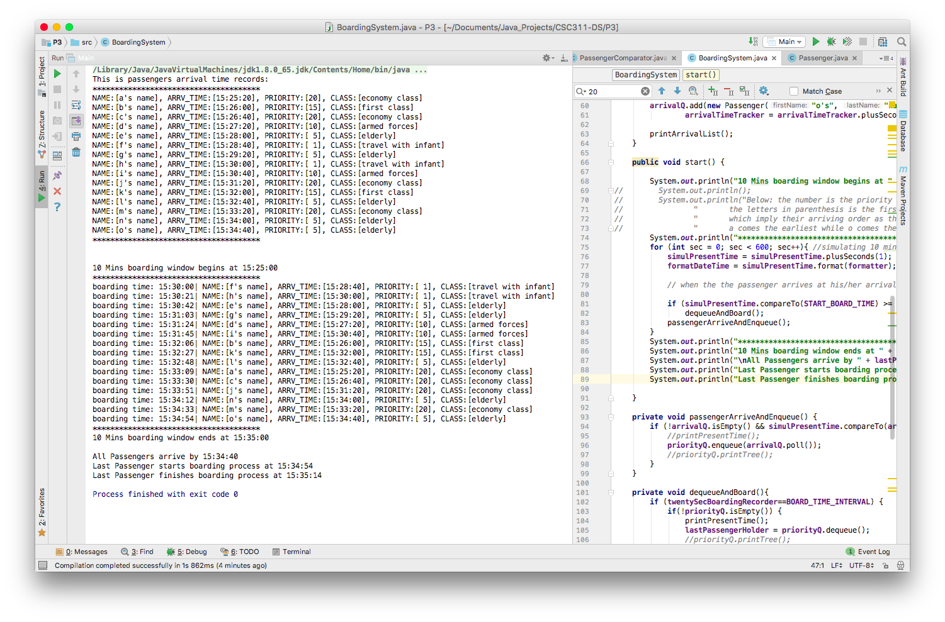

The project structure:

